**IF Arbiter Verification plan**

Raghda Kais

**25.01.2024**

**REV 1.0**

This document contains Intellectual Property (IP) that is owned and belongs to GuardKnox Cyber Technologies Ltd. GuardKnox Cyber Technologies owns this document and its information and therefore it is forbidden to copy, duplicate, transfer and/or disclose any information, fully or partially, that is included in this document without written consent from GuardKnox Cyber Technologies Ltd.



**© GuardKnox Cyber Technologies Ltd.**

Business Classification: Confidential

Changes History Table

| **Rev.** | **Date** | **initiator** | **Change description** | **Approver** |
| --- | --- | --- | --- | --- |
| **1** | **25/01/2024** | **Raghda Kais** | **Review 1** |  |
|  |  |  |  |  |
|  |  |  |  |  |
|  |  |  |  |  |
|  |  |  |  |  |
|  |  |  |  |  |

Content

1 Introduction 4

1.1 Scope and Objectives 4

1.2 Definitions, Acronyms & Abbreviations 4

1.3 Applicable Standard and Regulations 4

1.4 References 5

2 Dut Overview 6

2.1 Block diagram 6

2.2 Block Connection 6

2.3 Interfaces 7

2.4 Registers 8

3 Verification Plan 9

4 Verification Environment 10

4.1 Verification Environment Detailed Description 11

4.1.1 Verification Components Table 12

4.1.2 UVM Seq item 13

4.1.3 Simulation configuration 15

4.1.4 Compare testpoints 15

4.1.5 Interfaces vectors 15

4.1.6 Reference models 15

4.1.7 Data Flow and Operation 16

4.1.8 Pass/Fail criteria 16

5 Test Plan 17

6 Coverage 26

6.1 Code Coverage 26

6.2 Functional Coverage 26

Track functional coverage to ensure that the testcases cover different functional scenarios and configurations. 26

LIST OF FIGURES

Figure 1 – Top verification Environment diagram 7

Figure 2 – testbench diagram 8

Figure 3 – Reference model diagram 8

LIST OF TABLES

Table 1 – Definitions Table 4

Table 2 – Standard and Regulations Table 4

Table 2 – references documents Table 4

Table 4 – iterfaces Table 5

Table 5 – Registers Table 5

Table 6 – Verification Components Table 8

Table 6 – Testoints list Table 8

Table 7 – Test plan Table 10

Introduction

The document describes the verification goals for testing and the underlying requirements for generation, reference modelling and coverage.

## Scope and Objectives

This document describes the required functionality to be tested as well as required checkers, assertions. This document provides a detailed description of the verification environment(s) used to cover the verification of the design under test.

Definitions, Acronyms & Abbreviations

| **Acronym** | **Definition** |
| --- | --- |
|  |  |
|  |  |
|  |  |
|  |  |

***Table 1 – Definitions Table***

## Applicable Standard and Regulations

| **Ref.** | **Doc Name** | **Link to ref doc** |
| --- | --- | --- |
| **[A1]** | Automotive SPICE 3.1 VDA-HIS scope |  |
| **[A2]** | ISO 9001:2015 |  |
| **[A3]** | ISO 26262:2018 Functional Safety |  |

***Table 2 – Standard and Regulations Table***

## References

The following references contain useful information concerning the standard compatibility and other supportive documentation. The table contains links to all related documents, DUT specification, reference models specification, tests list spreadsheet, etc.

| **Ref.** | **Doc Name** | **Author(s)** | **safety item** | **Link to ref doc** |
| --- | --- | --- | --- | --- |
|  | Detailed Design Interface Arbiter |  |  | <https://guardknox365.sharepoint.com/:w:/r/sites/hwteam/_layouts/15/Doc.aspx?sourcedoc=%7B7CDFA0F9-E6C2-4E98-8875-EE6DD3940A63%7D&file=Detailed%20Design%20Interface%20Arbiter.docx&action=default&mobileredirect=true> |
|  | Testplan |  |  |  |
| **[R3]** |  |  |  |  |
| **[R4]** |  |  |  |  |
| **[R5]** |  |  |  |  |
| **[R6]** |  |  |  |  |

***Table 3 – references documents Table***

Dut Overview

The ‘Interface Arbiter’ determines which interface the data is received from next, making sure no interface is starved.

Each of the input source can be configured to either High (H) or Low (L) priority.

The arbiter prefers to select an interface request from the high priority group.

If there is no request from the high priority interface group (no data to send or neither one of the interfaced is configured as high priority) the arbiter selects from the low priority interfaces group.

If high priority and low priority interfaces groups were set together for long period of time (the high priority wins the selections), to avoid starvation of the low priority inputs, after predefined successive requests a selection from the low priority interfaces will be generated.

Within a priority, the selection of an interface is done using Round-Robin (RR) mechanism.

The ‘Interface Arbiter’ receives 3 data buses, each bit signifies one interface, the busses are:

                   ‘Interface Priority’ – indicates for each interface if it’s ‘High Priority or ‘Low Priority’

                   ‘Interface Status’ - indicates for each interface if it has anything to transmit

                   ‘Interface Enabled’ – indicates for each interface if it is enabled or not

The ‘Interface Arbiter’ outputs the number (based on the interfaces bit number in the bus) of interface the data should be received from

## Block diagram

**Figure 1 – High Level Block Diagram**

## Block Connection

**Figure 2 – L3 L4 checksum block connections**

## Interfaces

|  |
| --- |
| **Arbiter controller** |
|  |  |  |  |  |
| **idx** | **Name** | **Type** | **Dir** | **note** | |
| **1** | **interface_priority_bus** | **bit [if_count-1:0]** | **Input** |  | |
| **2** | **interface_status_bus** | **bit [if_count-1:0]** | **Input** |  | |
| **3** | **interface_enabled_bus** | **bit [if_count-1:0]** | **Input** |  | |
| **4** | **low_prio_timeout** | **bit [$clog2(if_count)-1:0]** | **Input** |  | |
| **5** | **selected_prio** | **bit** | **output** |  | |

***Table 1 – iterfaces Table***

|  |
| --- |
| **axis_iarb_if** |
|  |  |  |  |  |
| **idx** | **Name** | **Type** | **Dir** | **note** | |
| **1** | **m_axis_iarb_ready** | **bit** | **Input** |  | |
| **2** | **m_axis_iarb_valid** | **bit** | **output** |  | |
| **3** | **m_axis_iarb_interfaceid** | **bit [76:0]** | **output** |  | |

***Table 2 – iterfaces Table***

|  |
| --- |
| **Clk&rst** |
|  |  |  |  |  |
| **idx** | **Name** | **Type** | **Dir** | **note** | |
| **1** | **Sys_clk** | **bit** | **input** | **The ststem clok** | |
| **2** | **srst_n** | **bit** | **input** | **Synchronous reset_n** | |
| **3** | **asrst_n** | **bit** | **input** | **ASynchronous reset_n** | |

***Table 8 – iterfaces Table***



Verification Plan

**Verification environmant:**

**Verification methodolgy:**

Verification Environment

***Figure 3 – Top verification*** ***Environment diagram***

Verification Environment Detailed Description

***Figure 4 –verification*** ***Environment diagram***

### Verification Components Table

verification components with detailed description

| **idx** | **verification comp** | **Type** | **Description** |
| --- | --- | --- | --- |
| **1** | Axi_wrapper_agent | Uvm_agent | Agent class itself is a top-level container class for the components and they are the bottom of test bench hierarchy. the components are eth_driver, eth_sequencer, eth_monitor. |
| **2** | Axi_wrapper _driver | Uvm_drvier | eth_driver Collects the eth frame data from the sequencer and sends to the dut via the axi interfacel. |
| **3** | Axi_wrapper monitor | Uvm_monitor | eth_monitor is a component which receives eth frame via axi inf from the DUT and and parse it and then send to the scoreboard via analysis port. |
| **4** | Eth_item_coverage | Uvm_subscriber | Eth_item_coverage collects eth_items for collection of a coverpoints. |
| **5** | arbiter agent | Uvm_agent | Agent class itself is a top-level container class for the components and they are the bottom of test bench hierarchy. the components in this agent is only cs monitor |
| **6** | arbiter _monitor | Uvm_monitor | cs_monitor is a component which receives cs outputs from the send it to the scoreboard via analysis port. |
| **7** | arbiter _item_coverage | Uvm_subscriber | Cs_coverage collects cs_items for a collection of a coverpoints. |
|  | arbiter _Scoreboard | Uvm_scoreboard | Reciverd transcation of actual cs and compare with the transaction of the expected cs that generated in extract cs item inside axi wrapper agent. |
| **8** | test | Uvm_test | The test extends uvm_test. It consists of instances for sequences, environments and interfaces such as axi_stream_intf, further in the build phase object is created for components.  In the run phase the basic sequence is created and started on the sequencer within phase. raise_objection and phase. drop_objection. |
| **9** | Env | Uvm_env | environment is a container component for assembling sub component of test like CS_agent and axi_wrapper_agent. |

***Table 12 – Verification*** ***Components Table***

### UVM Seq item

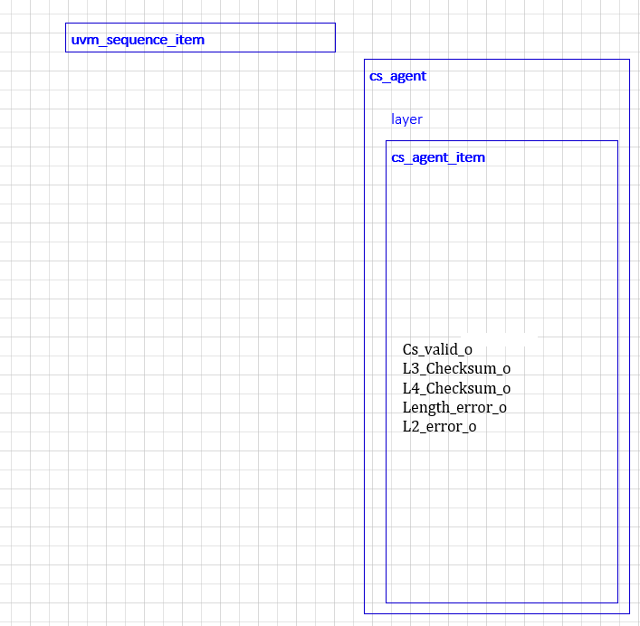

***Figure 6 –cs_seq_item***

### Simulation configuration

### Compare testpoints

| **idx** | **Testpoint name** | **RTL loaction** | **Agent associate** | **Description** |
| --- | --- | --- | --- | --- |
| **1** |  |  |  |  |
| **2** |  |  |  |  |
| **3** |  |  |  |  |
| **4** |  |  |  |  |
| **5** |  |  |  |  |
| **6** |  |  |  |  |

***Table 6 – Testoints list Table***

### Interfaces vectors

### Reference models

***Figure 3 – Reference model diagram***

### Data Flow and Operation

### Pass/Fail criteria

The verification process will be considered complete and ready for signoff when:

1. All Test Cases in the Testplan have been excuted and passed successfully.
2. Code Coverage Goals have been met.
3. Functional Coverage Goals have been achieved, covering the required Scenarios and configurations.
4. Any reported Bugs have been resovled and verifed.

Test Plan

**1.**

**Expected Result**:

**RANDOM TESTS:**

**1.**

**Expected Result:**

**CORNER TESTS:**

**1. :**

**Expected Result:**

Coverage

Code Coverage

Functional Coverage

Track functional coverage to ensure that the testcases cover different functional scenarios and configurations.

|  |  |  |  |  |
| --- | --- | --- | --- | --- |
|  |  |  |  |  |
|  |  |  |  |  |
|  |  |  |  |  |
|  |  |  |  |  |
|  |  |  |  |  |
|  |  |  |  |  |
|  |  |  |  |  |
|  |  |  |  |  |
|  |  |  |  |  |
|  |  |  |  |  |